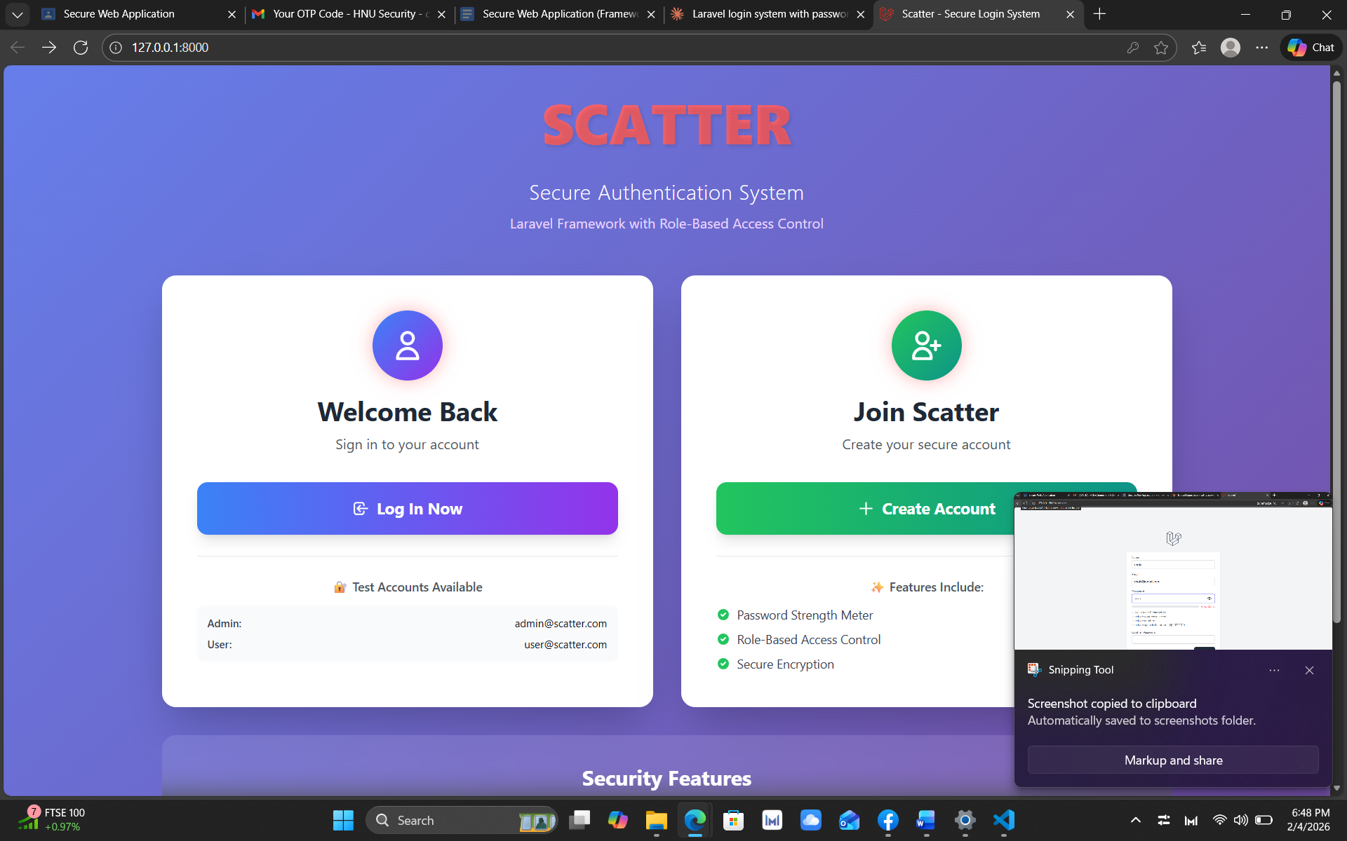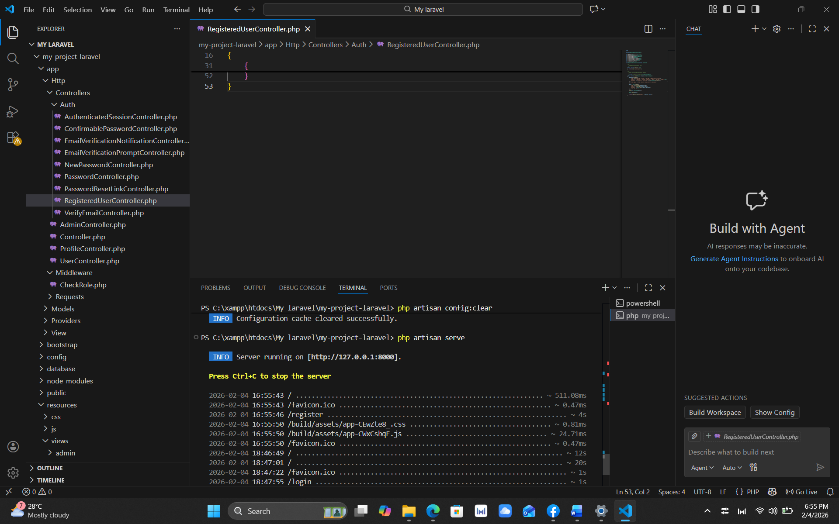

REPOSITORY LINK

Moki-kimo/IAS-checkpoint-initial at master

